Python 3.6.2 (v3.6.2:5fd33b5926, Jul 16 2017, 20:11:06)

[GCC 4.2.1 (Apple Inc. build 5666) (dot 3)] on darwin

Type "copyright", "credits" or "license()" for more information.

>>> WARNING: The version of Tcl/Tk (8.5.9) in use may be unstable.

Visit http://www.python.org/download/mac/tcltk/ for current information.

===== RESTART: /Users/gautamsoni/Desktop/CPSC 425/assignment1/a1_code.py =====

=============================== Part 1.1=======================================

>>> boxfilter(3)

array([[0.11111111, 0.11111111, 0.11111111],

[0.11111111, 0.11111111, 0.11111111],

[0.11111111, 0.11111111, 0.11111111]])

>>> boxfilter(4)

Traceback (most recent call last):

File "<pyshell#1>", line 1, in <module>

boxfilter(4)

File "/Users/gautamsoni/Desktop/CPSC 425/assignment1/a1_code.py", line 25, in boxfilter

raise exceptions.ArgumentError("Dimensions must be odd")

conda.exceptions.ArgumentError: Dimensions must be odd

>>> boxfilter(5)

array([[0.04, 0.04, 0.04, 0.04, 0.04],

[0.04, 0.04, 0.04, 0.04, 0.04],

[0.04, 0.04, 0.04, 0.04, 0.04],

[0.04, 0.04, 0.04, 0.04, 0.04],

[0.04, 0.04, 0.04, 0.04, 0.04]])

=============================== Part 1.2=======================================

>>> gauss1d(0.3)

array([0.00383626, 0.99232748, 0.00383626])

>>> gauss1d(0.5)

array([0.10650698, 0.78698604, 0.10650698])

>>> gauss1d(1)

array([0.00443305, 0.05400558, 0.24203623, 0.39905028, 0.24203623,

0.05400558, 0.00443305])

>>> gauss1d(2)

array([0.0022182 , 0.00877313, 0.02702316, 0.06482519, 0.12110939,

0.17621312, 0.19967563, 0.17621312, 0.12110939, 0.06482519,

0.02702316, 0.00877313, 0.0022182 ])

=============================== Part 1.3=======================================

>>> gauss2d(0.5)

array([[0.01134374, 0.08381951, 0.01134374],

[0.08381951, 0.61934703, 0.08381951],

[0.01134374, 0.08381951, 0.01134374]])

>>> gauss2d(1)

array([[1.96519161e-05, 2.39409349e-04, 1.07295826e-03, 1.76900911e-03,

1.07295826e-03, 2.39409349e-04, 1.96519161e-05],

[2.39409349e-04, 2.91660295e-03, 1.30713076e-02, 2.15509428e-02,

1.30713076e-02, 2.91660295e-03, 2.39409349e-04],

[1.07295826e-03, 1.30713076e-02, 5.85815363e-02, 9.65846250e-02,

5.85815363e-02, 1.30713076e-02, 1.07295826e-03],

[1.76900911e-03, 2.15509428e-02, 9.65846250e-02, 1.59241126e-01,

9.65846250e-02, 2.15509428e-02, 1.76900911e-03],

[1.07295826e-03, 1.30713076e-02, 5.85815363e-02, 9.65846250e-02,

5.85815363e-02, 1.30713076e-02, 1.07295826e-03],

[2.39409349e-04, 2.91660295e-03, 1.30713076e-02, 2.15509428e-02,

1.30713076e-02, 2.91660295e-03, 2.39409349e-04],

[1.96519161e-05, 2.39409349e-04, 1.07295826e-03, 1.76900911e-03,

1.07295826e-03, 2.39409349e-04, 1.96519161e-05]])

=============================== Part 1.4=======================================

>>> dog_image = Image.open('/Users/gautamsoni/Desktop/CPSC 425/assignment1/dog.jpg')

>>> dog_image.show()

>>> dog_image_grey = dog_image.convert("L")

>>> dog_image_array = np.asarray(dog_image_grey)

>>> gauss_dog = gaussconvolve2d(dog_image_array, 7)

>>> new_dog = Image.fromarray(gauss_dog.astype('uint8'))

>>> new_dog.save('/Users/gautamsoni/Desktop/CPSC 425/assignment1/new_dog_coloured.jpg')

>>> new_dog.show()



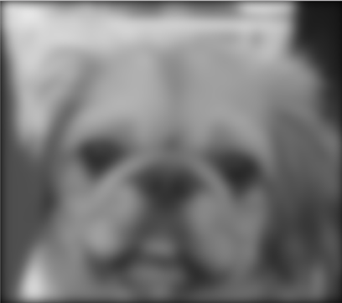

=============================== Part 1.5=======================================

With a seperable 2D Gaussian filter, there are 2m multiplications at each pixel

(X,Y). Also there are n x n pixels in (X,Y). Hence there are 2m * n^2

multiplications.

However, the convolution can be sped up by taking a natural log on both sides.

At the expense of two ln() and one exp() computations,

multiplication is reduced to admission.

=============================== Part 2.1=======================================

dog_image = Image.open('/Users/gautamsoni/Desktop/CPSC 425/assignment1/dog.jpg')

dog_image.show()

# Split the image in 3 channels

r, g, b = dog_image.split()

# Convert each channel (R,G,B) to an array

b_array = np.asarray(b)

g_array = np.asarray(g)

r_array = np.asarray(r)

# Apply filter to each channel

b_gauss = gaussconvolve2d(b_array, 7)[:,:,np.newaxis]

g_gauss = gaussconvolve2d(g_array, 7)[:,:,np.newaxis]

r_gauss = gaussconvolve2d(r_array, 7)[:,:,np.newaxis]

# Compose the 3 channels to get a colored picture

new_blurr_dog = np.concatenate((r_gauss, g_gauss, b_gauss), axis=2)

blurr_dog_image = Image.fromarray(new_blurr_dog.astype('uint8'))

blurr_dog_image.show()

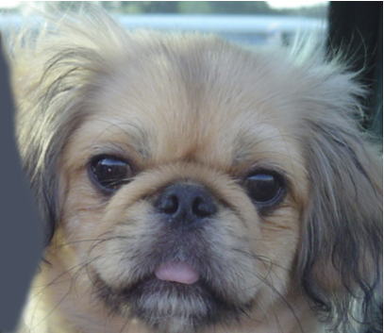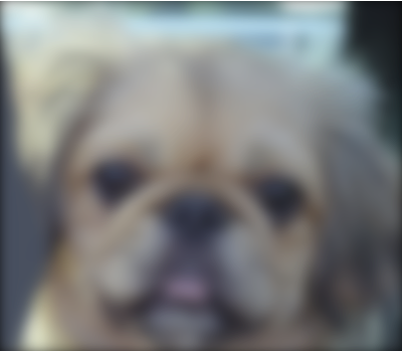

=============================== Part 2.2=======================================

cat_image = Image.open("/Users/gautamsoni/Desktop/CPSC 425/assignment1/hw1/0a_cat.bmp")

cat_image.show()

cat_image_array = np.asarray(cat_image)

# Split the image in 3 channels

r_cat, g_cat, b_cat = cat_image.split()

# Convert each channel (R,G,B) to an array

b_array_cat = np.asarray(b_cat)

g_array_cat = np.asarray(g_cat)

r_array_cat = np.asarray(r_cat)

# Apply filter to each channel

b_gauss_cat = gaussconvolve2d(b_array_cat, 7)[:,:,np.newaxis]

g_gauss_cat = gaussconvolve2d(g_array_cat, 7)[:,:,np.newaxis]

r_gauss_cat = gaussconvolve2d(r_array_cat, 7)[:,:,np.newaxis]

# Compose the 3 channels to get a colored picture

new_blurr_cat = np.concatenate((r_gauss_cat, g_gauss_cat, b_gauss_cat), axis=2)

new_blurr_cat_image = Image.fromarray(new_blurr_cat.astype('uint8'))

new_blurr_cat_image.show()

high_frequency_cat = np.subtract(cat_image_array,new_blurr_cat)

high_frequency_cat_image = Image.fromarray(high_frequency_cat.astype('uint8') + 128)

high_frequency_cat_image.show()

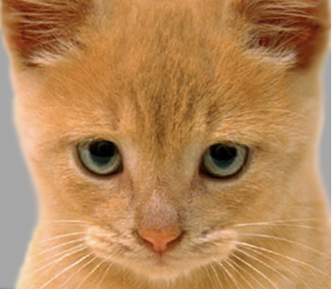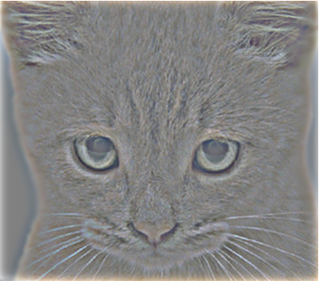

=============================== Part 2.3=======================================

# Add the low frequency and high frequency images to create a hybrid image

hybrid_image_array = np.add(high_frequency_cat, new_blurr_dog)

hybrid_image = Image.fromarray(hybrid_image_array.astype('uint8'))

hybrid_image.show()

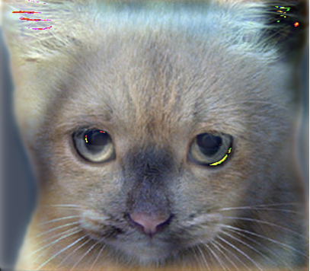

==============================================================================

Part 2

Cat and Dog images

Sigma = 4

2.1

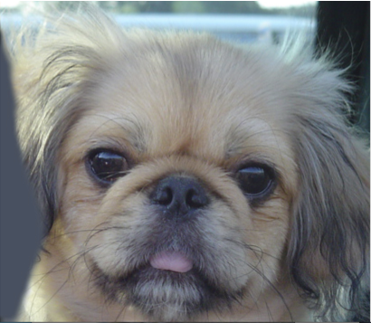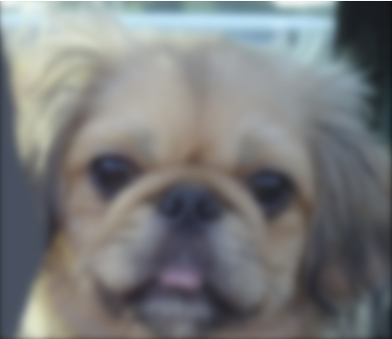

2.2

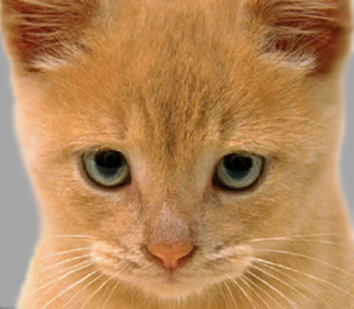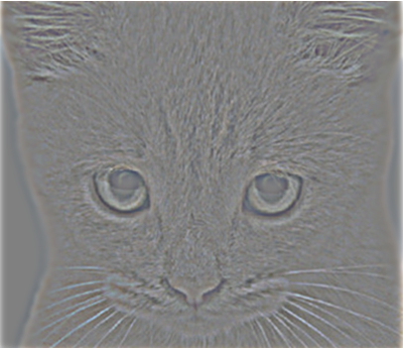

2.3

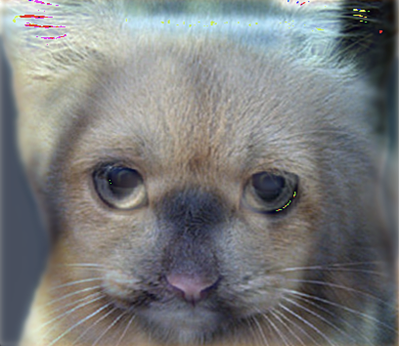

==============================================================================

Part 2

Cat and Dog images

Sigma = 1

2.1

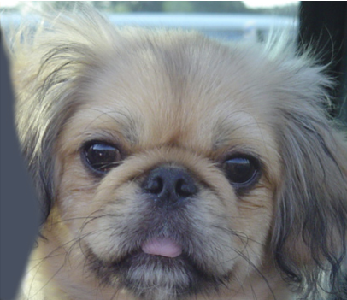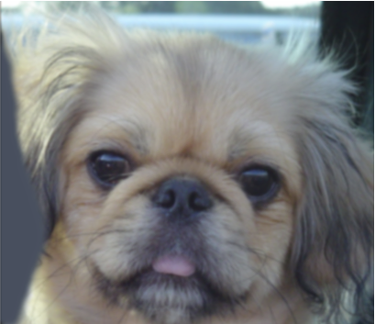

2.2

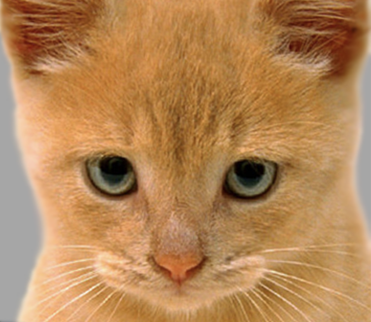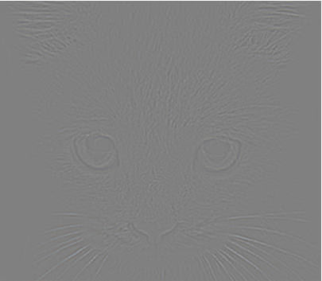

2.3

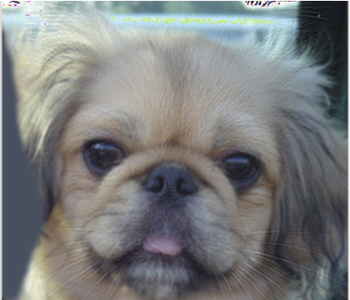

==============================================================================

Part 2

Einstein and Marilyn

Sigma = 7

2.1

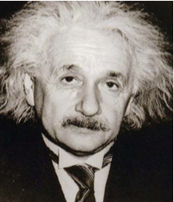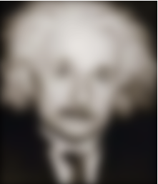

2.2

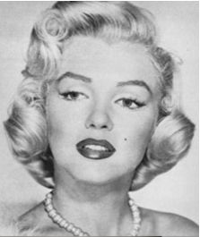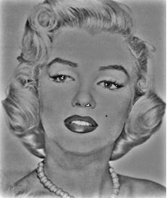

2.3

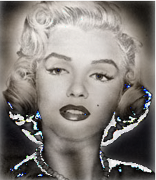

==============================================================================

Part 2

Einstein and Marilyn

Sigma = 4

2.1

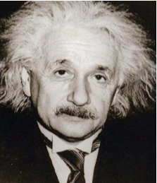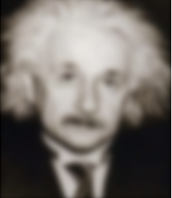

2.2

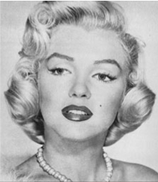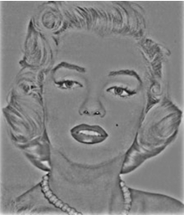

2.3

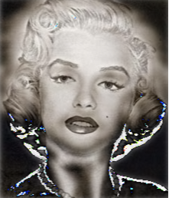

==============================================================================

Part 2

Einstein and Marilyn

Sigma = 1

2.1

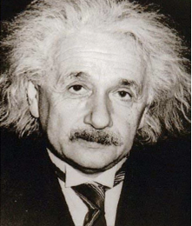 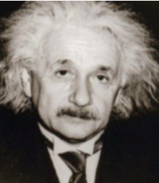

2.2

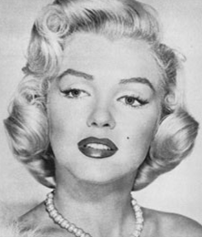 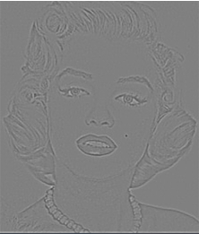

2.3

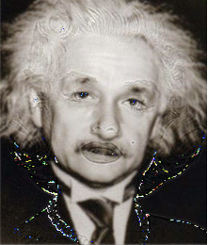

==============================================================================

Part 2

Bird and Plane

Sigma = 7

2.1

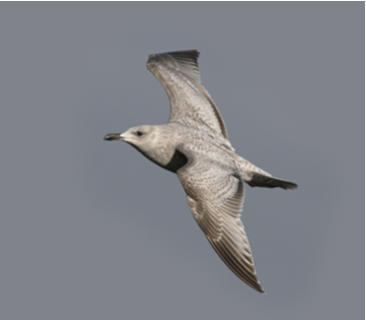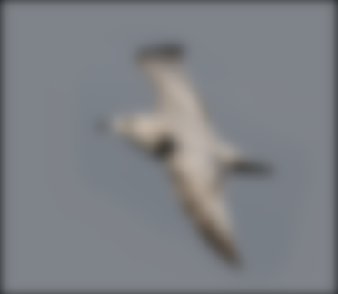

2.2

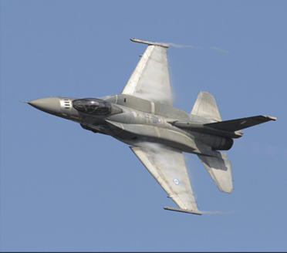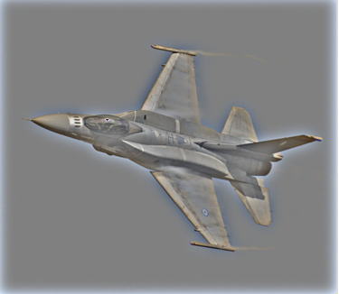

2.3

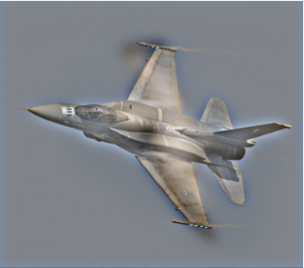

==============================================================================

Part 2

Bird and Plane

Sigma = 10

2.1

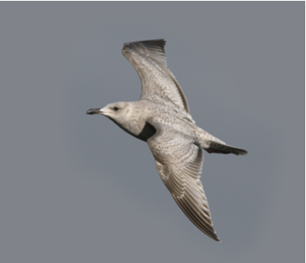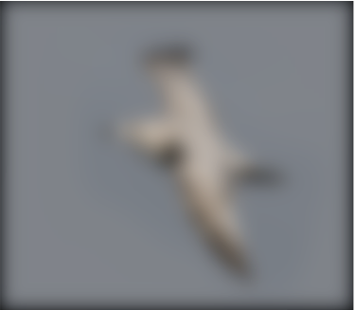

2.2

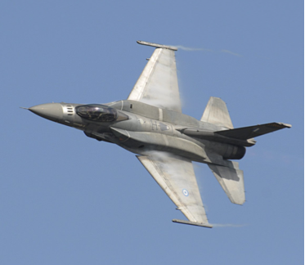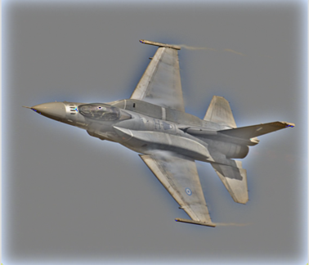

2.3

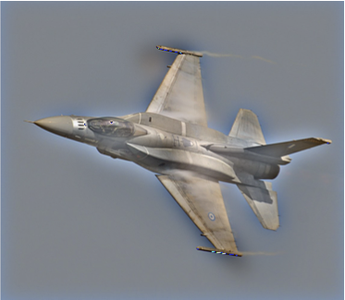

==============================================================================

Part 2

Bird and Plane

Sigma = 2

2.1

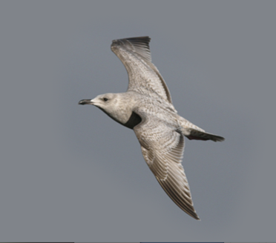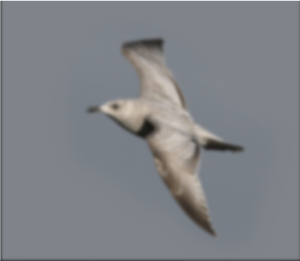

2.2

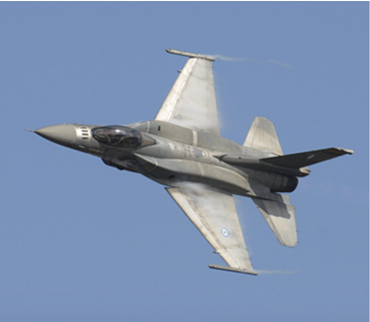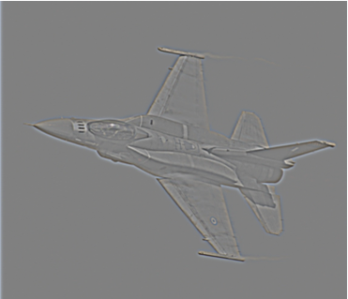

2.3

